use emp switched to db empl

> db.createCollection("empl") { "ok" : 1 } > db.empl.insert({empid:100,name:"akhil",salary:7000,role:"sd"}) WriteResult({ "nInserted" : 1 }) > db.empl.insert({empid:101,name:"msd",salary:7000,role:"test"}) WriteResult({ "nInserted" : 1 }) > db.empl.insert({empid:102,name:"sneha",salary:5000,role:"ce"}) WriteResult({ "nInserted" : 1 }) > db.empl.insert({empid:103,name:"remya",salary:15000,role:"se"}) WriteResult({ "nInserted" : 1 }) > db.empl.insert({empid:104,name:"rd",salary:35000,role:"ceo"}) WriteResult({ "nInserted" : 1 }) > db.empl.insert({empid:105,name:"arun",salary:55000,role:"cfo"}) WriteResult({ "nInserted" : 1 }) > db.empl.insert({empid:106,name:"sanal",salary:5000,role:"tr"}) WriteResult({ "nInserted" : 1 }) Q1.> db.empl.find().pretty()

> db.empl.find().pretty() { "_id" : ObjectId("ddc13dfe639f443d93898788"), "empid" : 100, "name" : "akhil", "salary" : 7000, "role" : "sd" } { "_id" : ObjectId("ddc13f3d639f443d93898789"), "empid" : 101, "name" : "msd", "salary" : 7000, "role" : "test" } { "_id" : ObjectId("ddc13f74639f443d9389878a"), "empid" : 102, "name" : "sneha", "salary" : 5000, "role" : "ce" } { "_id" : ObjectId("ddc13fba639f443d9389878b"), "empid" : 103, "name" : "remya", "salary" : 15000, "role" : "se" } { "_id" : ObjectId("ddc1402d639f443d9389878c"), "empid" : 104, "name" : "rd", "salary" : 35000, "role" : "ceo" } { "_id" : ObjectId("ddc1404f639f443d9389878d"), "empid" : 105, "name" : "arun", "salary" : 55000, "role" : "cfo" } { "_id" : ObjectId("ddc1406e639f443d9389878e"), "empid" : 106, "name" : "sanal", "salary" : 5000, "role" : "tr"

Db.emp.updte({name:”sce”},{$inc:{“sacary”:8000}});

Q2> db.empl.updateOne({name:"sneha"},{$inc:{"salary":8000}}); { "acknowledged" : true, "matchedCount" : 1, "modifiedCount" : 1 } > db.empl.find({name:"sneha"}).pretty() { "_id" : ObjectId("ddc14568639f443d9389878f"), "empid" : 102, "name" : "sneha", "salary" : 13000, "role" : "ce" } >

Q3. >db.empl.updateOne({},{$inc:{"salary":4000}}); { "acknowledged" : true, "matchedCount" : 1, "modifiedCount" : 1 }

> db.empl.find().pretty() { "_id" : ObjectId("ddc13dfe639f443d93898788"), "empid" : 100, "name" : "akhil", "salary" : 11000, "role" : "sd" }

Q4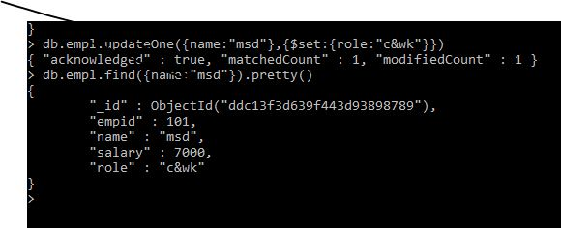

Q5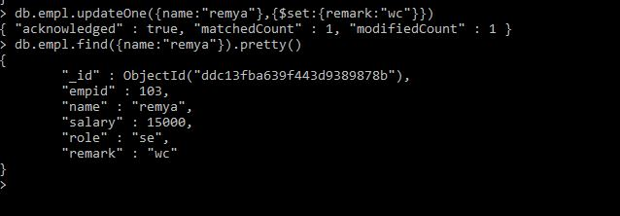

Q6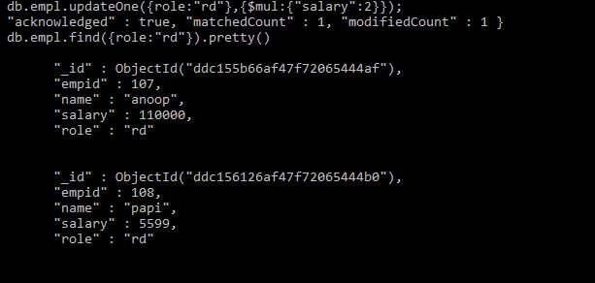

Q8